**MINI PROJECT – I**

**(2019-20)**

# Secure Internet

**MID TERM REPORT**



**Institute of Engineering & Technology**

**Team Members**

Akshay Dubey (171500029)

Himanshu Pathak (171500136)

Ganesh Pandey (171500106)

Saurabh Singhal (171500304)

## Supervised By

**Dr. Manoj Varshney**

**(Technical Trainer)**

**Department of Computer Engineering & Applications**

**ACKNOWLEDGEMENT**

We have taken efforts in this project. However, it would not have been possible without the kind support and help of many individuals and organizations. We would like to extend our sincere thanks to all of them.

We are highly indebted to **Dr. Manoj Varshney** for their guidance and constant supervision as well as for providing necessary information regarding the project & also for their support in completing the project.

We would like to express our special gratitude and thanks to industry persons for giving me such attention and time.

Our thanks and appreciations also go to my colleague in developing the project and people who have willingly helped us out with their abilities.

**CERTIFICATE**

This is to certify that **Akshay Dubey , Himanshu Pathak , Ganesh Pandey, Saurabh Singhal**

students of B.Tech(CSE) 3rd Year , GLA University , Mathura have partially completed the

Project on “Secure Internet – Website Filtering Tool” under the guidance of “**Dr. Manoj Varshney**”

,Technical Trainer GLA University, Mathura .

**Dr. Manoj Varshney**

**(Signature)**

**Contents**

1. **Acknowledgement………………………………………………….……..2**
2. **Certificate…………………………………………………………….……3**
3. **Problem Statement…………………………………………………….….5**
4. **Reason for selecting the topic………………………………………….…5**
5. **Objective of Project…………………………………………………….…5**
6. **Future Scope……………………………………………………………....5**
7. **Hardware & Software Requirements…………………………………....6**
8. **Contribution of project…………………………………………………...6**
9. **Scope of extension of project……………………………………………..6**
10. **Implementation…………………………………………………….……...7**
11. **Contribution…………………………………………………...…………12**
12. **Work Detail……………………………………………………...……….12**
13. **Conclusion………………………………………………………...……...12**
14. **References………………………………………………………………..13**

**Problem Statement**

Web Content Filtering range from wanting to improve internal productivity, keep users off of dangerous and illegal sites or restrict sites based on the morals of those in charge of the organization. In general, the need to block content for whatever reason, can be met with Web Content Filtering.

**Reason for selecting the topic**

Safe Internet can be used as a parental control solution that helps parents protect their children and monitor their Internet use. This can also be used in corporate and educational environment to reduce the Internet Slacking. An Internet content filtering tool gives organizations the ability to prevent web users visiting online destinations that may harbor hidden security risks or unacceptable content. As a precaution against the inadvertent downloading of malware, adware, and ransomware, tools for filtering Internet content are becoming necessary elements of an organization´s cybersecurity defenses.

**Objective of the Project**

The following tasks that will be performed by this tool are :

* Block particular websites
* Block websites that contain unauthorized or illegal content
* Which and when the unauthorized or illegal website is accessed
* Enable user to browse securily.

**Future Scope**

After making this tool parents and teachers are able to restrict their children and students respectively from accessing unauthorized or illegal websites that makes the bad impact on their mindset.

We can also use this tool in an organization that will restrict their employees from using the particular websites like social networking sites during work hours, that will increase their productivity and reduce Internet Slacking.

An Internet filter tool can also increase workplace productivity and avoid potential HR issues. These goals are achieved by blocking access to personal social media accounts, online shopping portals, sites containing pornographic material and video streaming websites.

**Hardware & Software to be used**

**Hardware**:

* Laptop with 8GB RAM

**Software**:

* Python (Spyder IDE)
* HTML/CSS
* SQL (MySQL)

**What contribution would the project make and where**

After making this tool parents and teachers are able to restrict their children and students respectively from accessing unauthorized or illegal websites that makes the bad impact on their mindset.

We can also use this tool in an organization that will restrict their employees from using the particular websites like social networking sites during work hours, that will increase their productivity and reduce Internet Slacking.

**Scope for extension into a major project**

As the tech is increasing day by day,the websites and web contents are also increasing on the internet.This set of websites contain multiple malicious and illegal websites which we don’t want to browse or let the user using your PC not to browse it. This tool can be also be framed into a Chrome extension in future which can be viewed and used worldwide.

**Implementation**

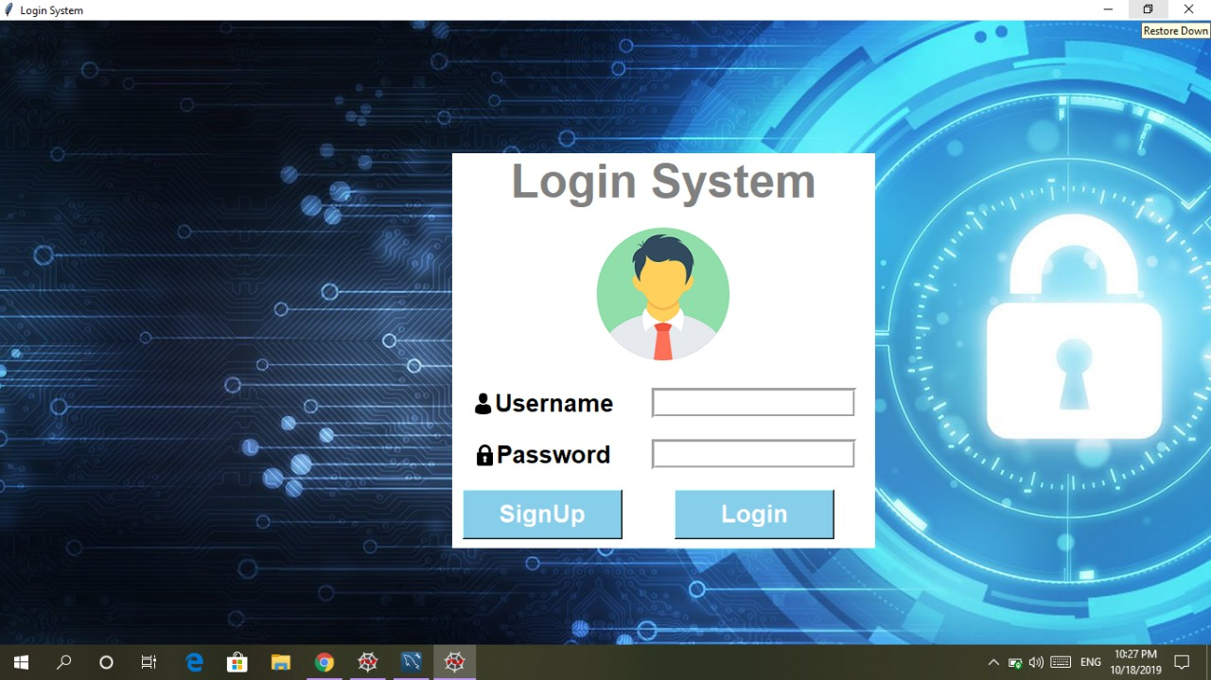

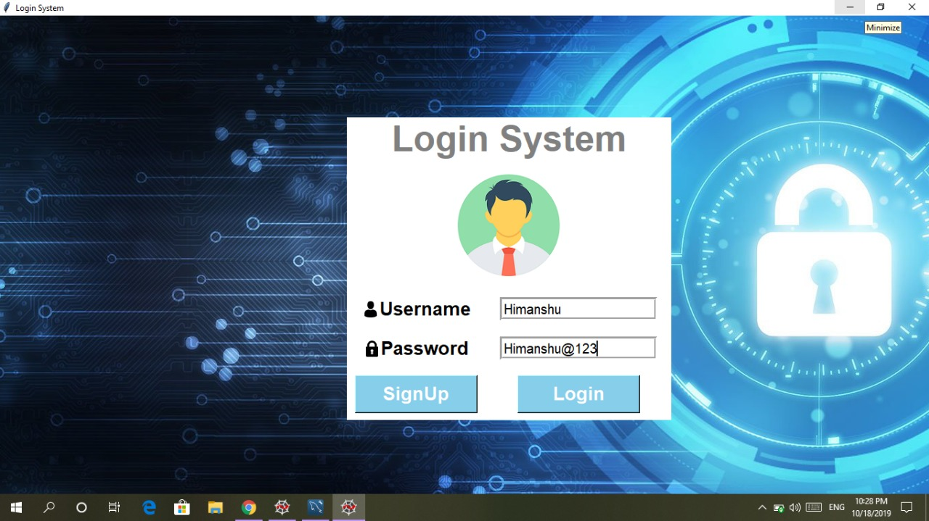

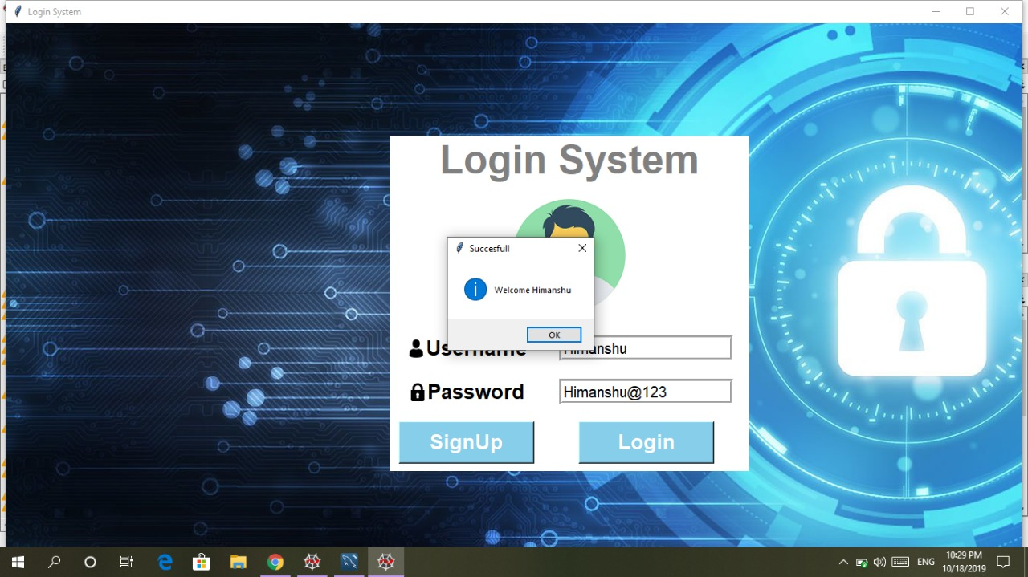

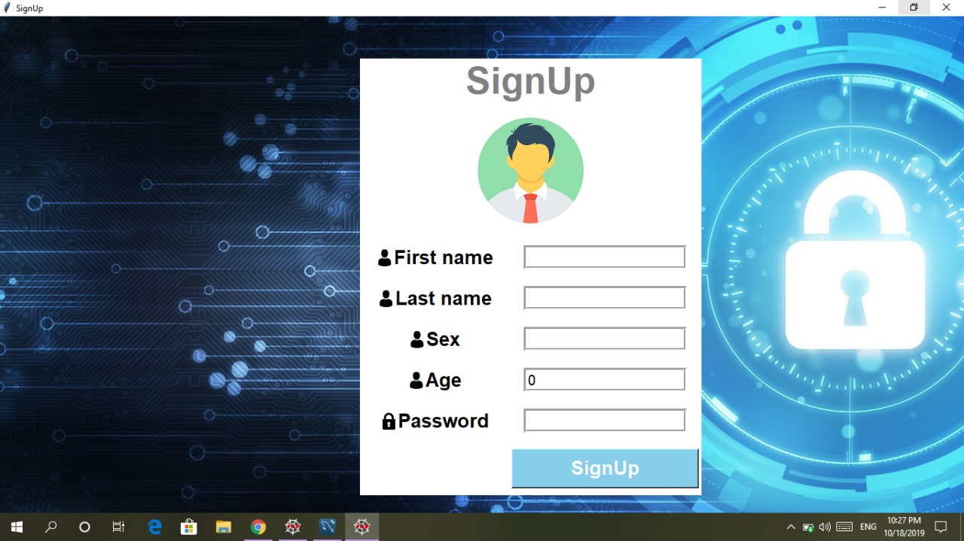

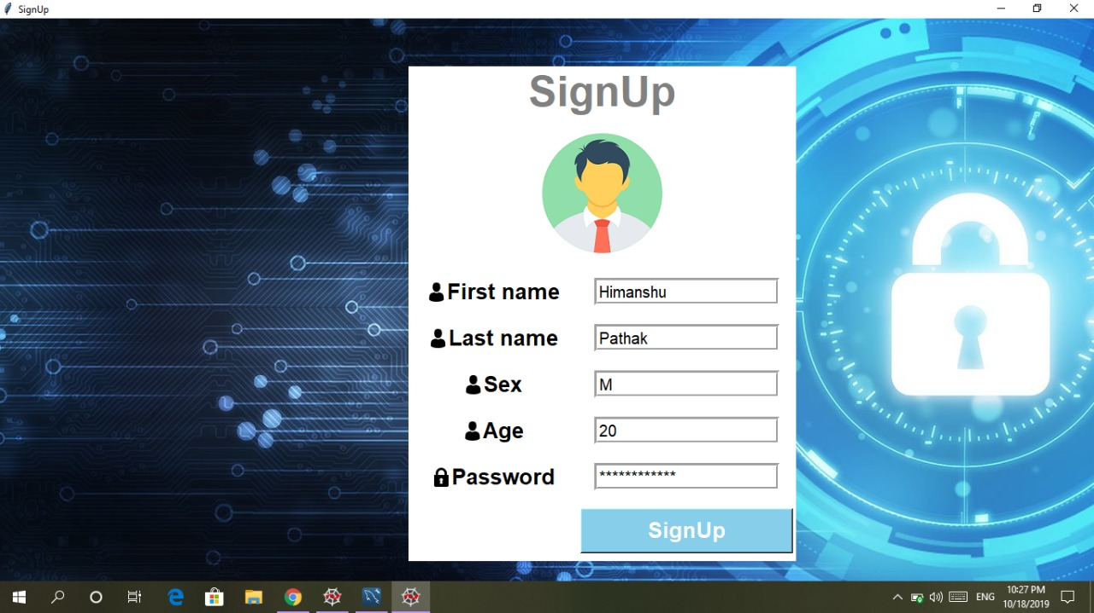

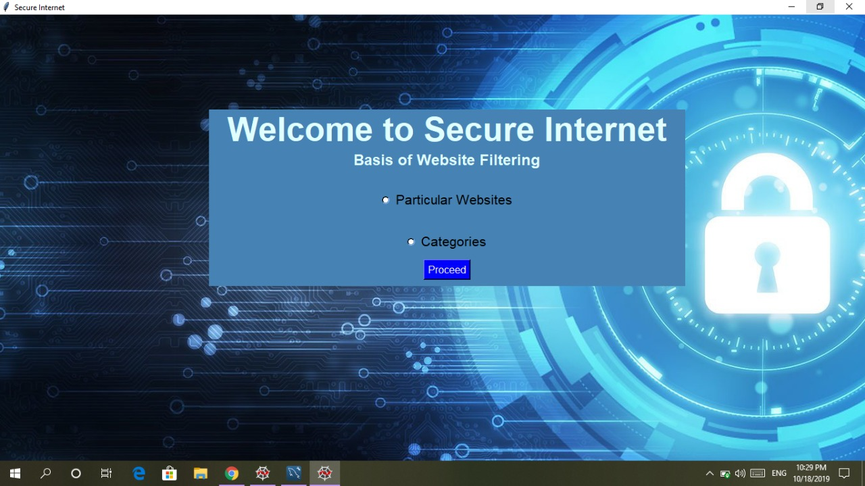

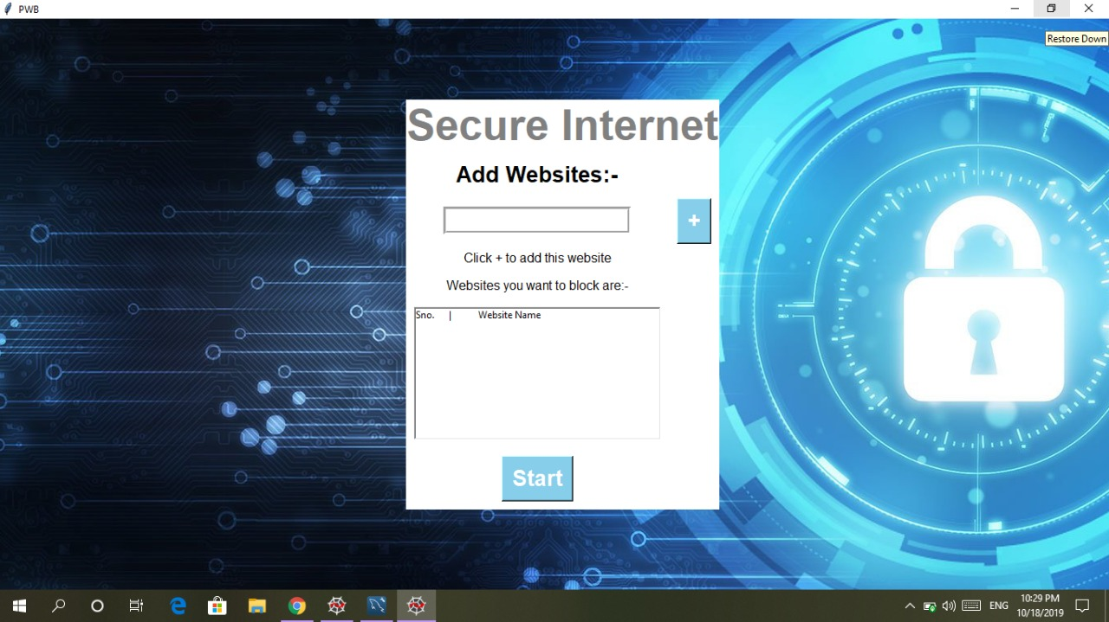

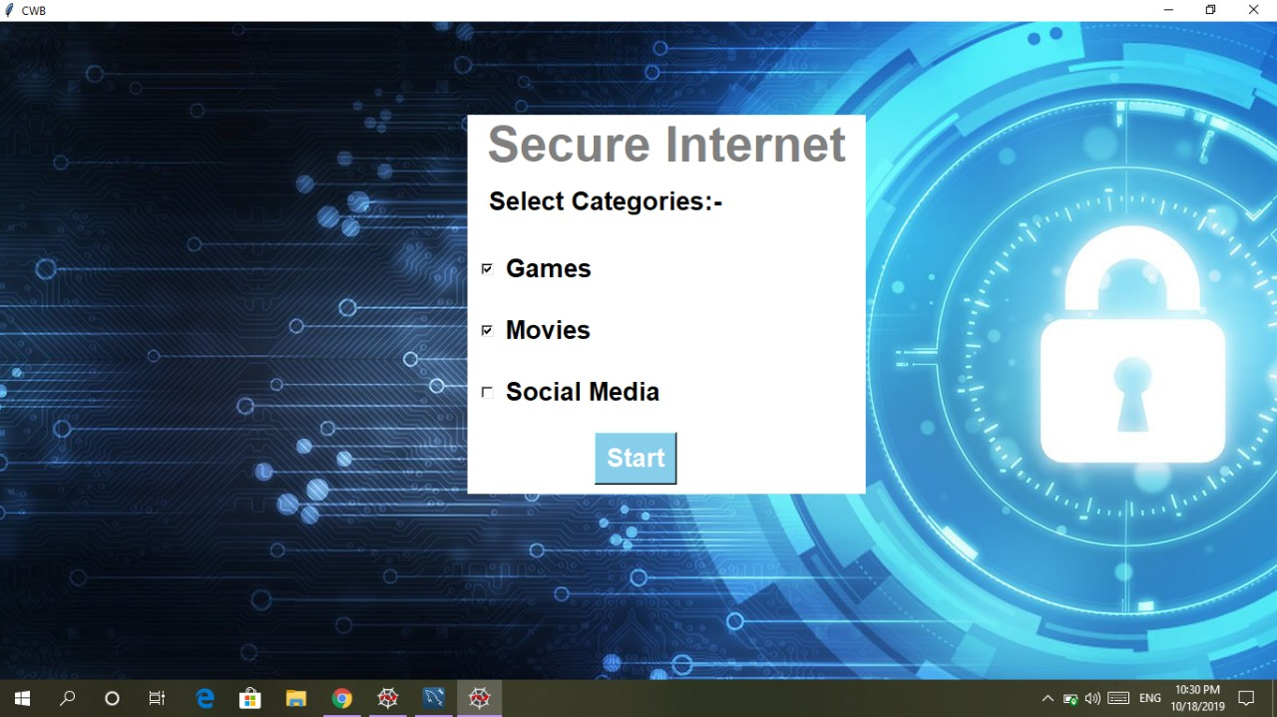

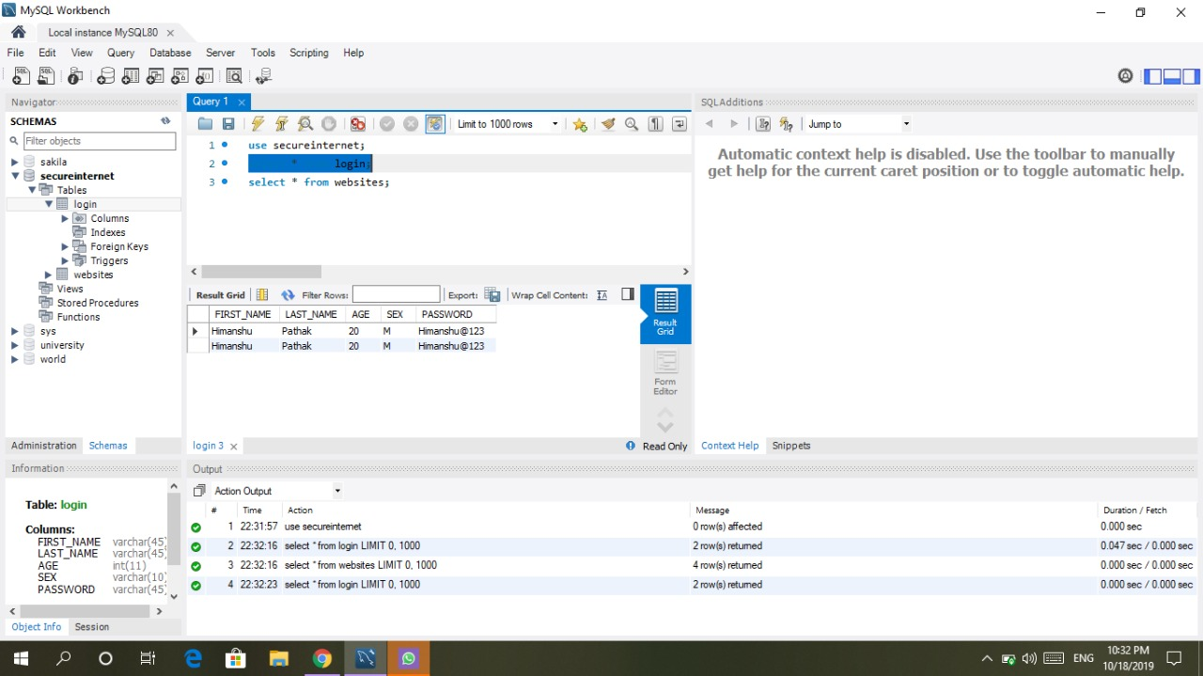

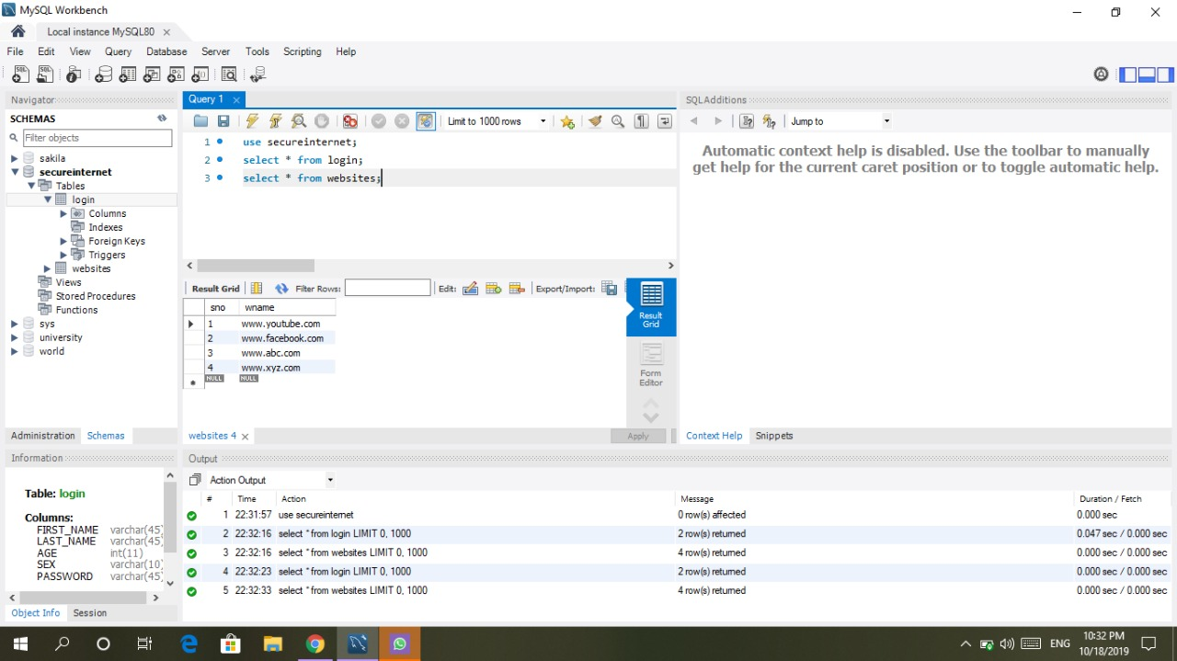

**Contribution of Members**

* Akshay Dubey
  + Login Window + SignUp Window
* Himanshu Pathak
  + Particular Website Block Window
* Ganesh Pandey
  + Categories Wise Block Window
* Saurabh Singhal
  + Basis of Website Filtering Window

**Work Detail**

As you can see that we have implemented the User Interface of our Project.

The module to “Block Websites” is left to be implemented.

The particular website that we want to block can be redirected to a alert window which can be seen by user.

On the other hand the particular category that we want to block can be done by the “Block Module” where it checks the Head tag of the HTML page , and if it matches to the Blocked Category it will be redirected to the alert page .

**Conclusion**

As title suggests the aim of project is to make browsing internet secure.This can be achieved by blocking the content or websites which are illegal,unethical,unwanted,malicious and unauthorised.Blocking websites is not a easy task.This can be done by checking the head content in the source code of website.

We will check the source code of website using beautifulsoup library in python and analyze that whether the content of website is legal or not.If the website does not contain any illegal content then we will allow user to freely surf it,

Otherwise we will redirect to our designed alertpage that shows the website you are accessing contains illegal,unauthorized and unethical content and you are not allowed to access this website or webpage.

We will also store the date and time with website name in database when the user opens blocked website which can be viewed only by superuser who have installed this tool on that PC.

This tool can be used by the organizations to block a particular websites that they don’t allow their employees to access on organization’s PC.This can be done by adding the particular website to this tool.This will reduce Internet Slacking.

**References**

* <https://www.spamtitan.com/internet-content-filtering-tool/>
* <https://searchsecurity.techtarget.com/definition/Web-filter>